Tic Tac Toe Program Python – Cody Martin

Generate window

Prompt start game option

If no, close program

If yes, draw board

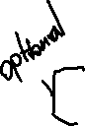

*Assign player 1 X or O (Random generator?)*

*Notify player of assigned letter*

Prompt player to begin game by clicking square on grid where they would like to place their letter

Draw letter on click

Notify player two to pick

Upon click check if square is occupied (if so, prompt to select different grid)

Check for win (if win, notify who is winner ask to play again or close)

Check for tie (if tie, ask to play again or close)

If play again, loop to assign player a letter

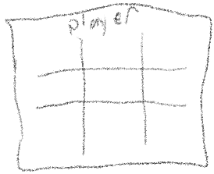If not a win, loop through the location select process

